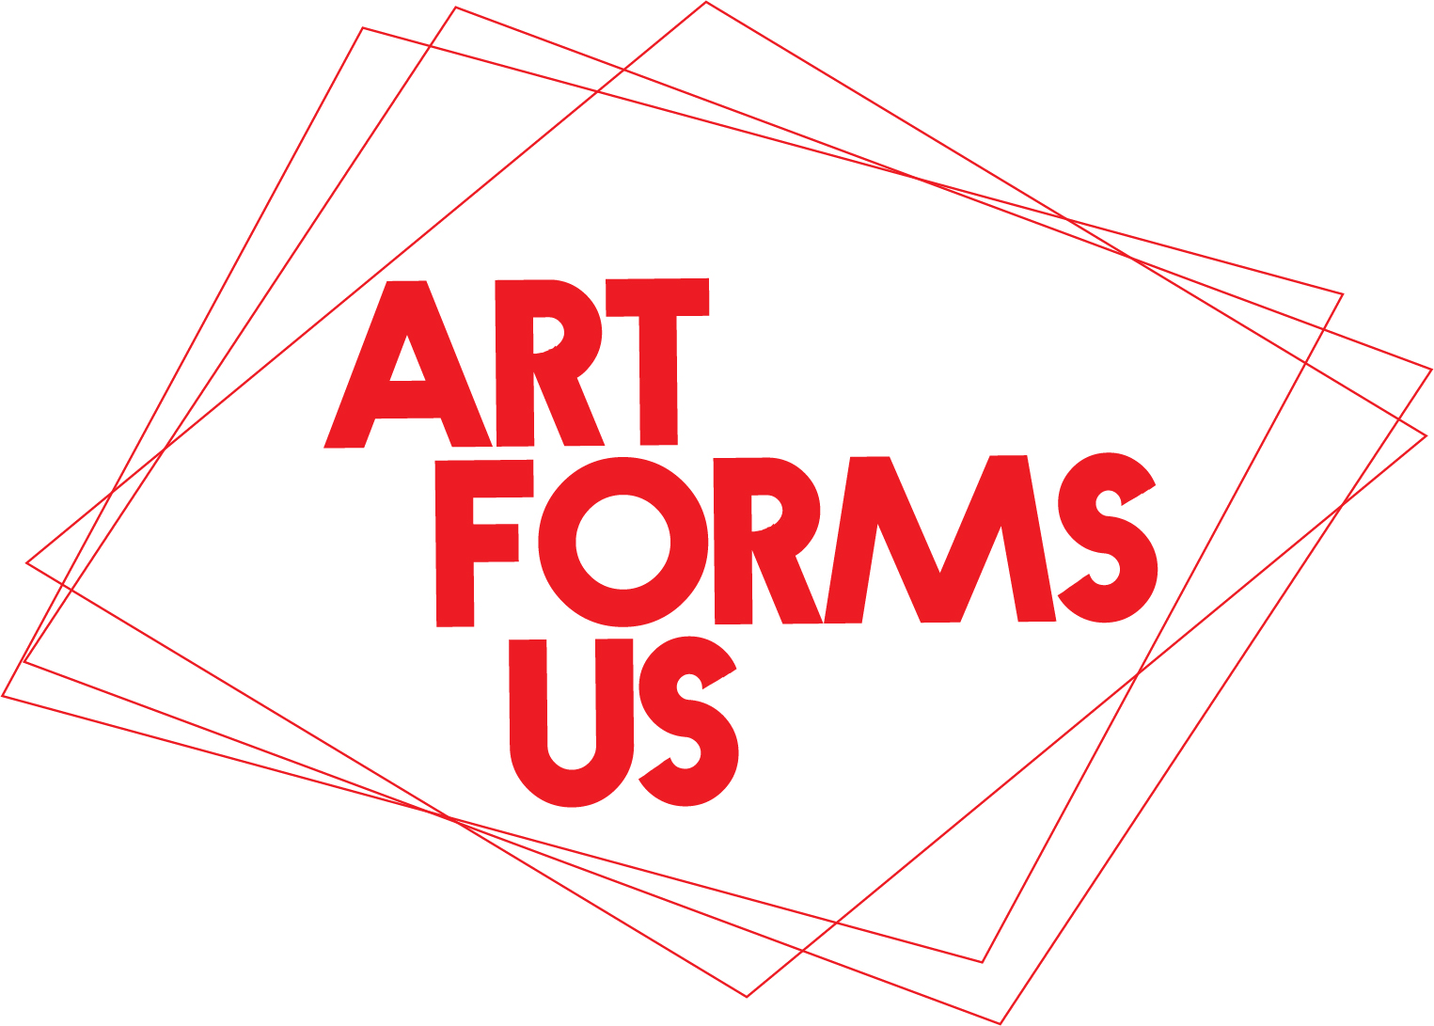

FOR IMMEDIATE RELEASE
Contact:Leah Poller
Email: ArtFormsUs@gmail.com

New York, 9/20/2020

ArtFormsUs launches publicly with “Project Projection”, a visually
powerful selection of artworks illuminating a Harlem backdrop

Emanating from an ongoing cultural conversation, 11 Harlem-based artists
introduce their respective works in a nocturnal showing Saturday, September 26

A group of multi-national, multi-talented artists residing in Harlem began a monthly meet-up to converse about art and their roles as Agents of Culture. With the onset of Covid 19, meetings became Zoom-based and more frequent.

Sensitive to the community’s need to experience art, and the artists’ need to commune with their audiences in these uncertain times, “Project Projection” emerged: An evening of art illuminating a vacant storefront, with the ideal venue provided by Harlem restaurant Settepani, (196 Malcolm X Boulevard, at 120th St).

The public is invited to attend “Project Projection”, the official public launch of ArtFormsUs on Saturday, September 26, at 7:30, presenting a selection of works from the multi-talented, multi-media participants including visual artist Allicette Torres, inaugurating her fiery video “And the Rockets…”, while photographer Undine Groeger presents images examining “reconciliation”; artist Viviane Rombaldi Seppey and mixed-media artist Sade Boyewa El project sensitive works of the inner lives of people and places both familiar and not, while collage/media artists Capucine Bourcart and Tomo Mori create contemplative wholes from fragments of memories. Photographer Salem Krieger reinvents language in a forceful baptism by fire, as Dominque de Cock uses smoke and fragile tissue paper support to capture traces of the ephemeral. Multi-media artist Noreen Dean Dresser confronts the commercial inroads against the natural world with paint and postage stamps. Conceptual artist Xavier Roux engages the personal connection, and sculptor Leah Poller explores the personal using hyper-figurative portraiture to reveal inner thoughts.

The rich, cultural tapestry of these artists is woven, thread by thread, in a stimulating nighttime projection offered to invited guests and passersby to illuminate the cultural strength of this neighborhood. “Project Projection” provides a cohesive whole arising from disparate parts which keep our communities alive and in communication with each other.

FOR FURTHER INFORMATION:
Web site: www.ArtFormsUs.com
Email: ArtFormsUs@gmail.com

ABOUT:
ArtFormsUs is a collective of Harlem-based artists who meet regularly in an open conversation about their artistic paths and their roles as Agents of Culture. This “work in progress” gives shape and form to a community of ideas and experiences in the creative realm.

ArtFormsUs thanks Settepani, One Life Wellness, solutionsNOW, Harlem Heritage Tours and BLACKISSUESISSUESISSUES™ for their sponsorship.

We adhere to all state mandated social distancing and mask wearing protocols.

